
UNIVERSITY INSTITUTE OF COMPUTING

PROJECT REPORT

ATM Simulator using C++



SUBMITTED BY:
NAME: Loveleen Kaur

UID:23BCA10244

SECTION: 23BCA 7’A’

Project Report on ATM Simulator using C and C++

1. Title Page
Project Title: ATM Simulator using C and C++
Team Members : Anjali Choudhary (23 BCA 10078) & Loveleen Kaur (23BCA 10244)
Section: 23BCA 7 ‘A’
Institution: University Institute of Computing
Subject: Computing Aptitude

2. Abstract
This project, “ATM Simulator using C and C++,” is designed to replicate the basic functions of an Automated Teller Machine.
The system allows users to perform operations such as account creation, balance inquiry, cash withdrawal, deposit, and PIN verification.
The simulator provides a menu-driven interface to make transactions simple and efficient. It demonstrates the use of file handling, structures,
and object-oriented programming concepts in C and C++.

3. Introduction
The Automated Teller Machine (ATM) is one of the most widely used banking innovations. It enables customers to perform financial transactions
without visiting a bank branch. This project aims to simulate an ATM system using C and C++ programming languages. The program offers basic
banking services such as checking balance, withdrawing and depositing money, and changing PIN numbers. The purpose is to help students
understand programming logic, file handling, and OOP principles through a practical example.

4. Problem Statement/Objectives
Problem Statement:
To design and implement a computerized ATM simulator that allows users to interact with their bank accounts through simple commands, mimicking real-world ATM operations.
Objectives:
- To simulate ATM operations like withdrawal, deposit, and balance check.
- To provide user authentication using a PIN system.
- To use file handling for storing and retrieving account data.
- To demonstrate object-oriented programming concepts like classes and objects.

5. System Design/Approach
System Architecture: The system follows a menu-driven approach where the user selects an option from a displayed menu.
Modules:
1. Account Creation – To create a new account and save user details.
2. PIN Verification – To ensure security using a user-entered PIN.
3. Balance Inquiry – To check current account balance.
4. Deposit and Withdrawal – To modify the balance amount.
5. Exit – To safely terminate the program.
Flowchart:
Start → Show Main Menu → Enter Account Number & PIN → Authenticate User → Perform Operation (Withdraw/Deposit/Check Balance) → Update File Records → Show Confirmation → Exit
Class Diagram (Simplified):
Class Account {
private:
int accNo;
char name[30];
int pin;
float balance;
public:
void createAccount();
void showAccount();
void deposit(float amt);
void withdraw(float amt);
int getAccNo();
int getPin();
};

6. Implementation
Language Used: C and C++
Key Concepts: File Handling, Classes, Functions, Conditional Statements, Loops
Sample Code Snippet (C++):
#include <iostream> // Required for input/output operations
#include <limits> // Required for numeric_limits

using namespace std; // Use the standard namespace

int main () {
float balance = 1000.00; // Initial account balance
int choice; // User's menu choice
float amount; // Amount for withdrawal or deposit

cout << "Welcome to the Simple ATM Simulator!" << endl;

while (true) { // Loop indefinitely until the user chooses to exit
cout << "\n--- ATM Menu ---" << endl;
cout << "1. Check Balance" << endl;
cout << "2. Withdraw" << endl;
cout << "3. Deposit" << endl;
cout << "4. Exit" << endl;
cout << "Enter your choice: ";

// Input validation for choice
while (!(cin >> choice)) {
cout << "Invalid input. Please enter a number (1-4): ";
cin. clear (); // Clear the error flag
cin.ignore(numeric_limits<streamsize>::max(), '\n'); // Discard invalid input
}

switch (choice) {
case 1:
cout << "Your current balance is: $" << balance << endl;
break;
case 2:
cout << "Enter amount to withdraw: $";
while (!(cin >> amount) || amount <= 0) {
cout << "Invalid amount. Please enter a positive number: $";
cin.clear();
cin.ignore(numeric_limits<streamsize>::max(), '\n');
}
if (amount > balance) {
cout << "Insufficient funds." << endl;
} else {
balance -= amount;
cout << "Withdrawal successful. Your new balance is: $" << balance << endl;
}
break;
case 3:
cout << "Enter amount to deposit: $";
while (!(cin >> amount) || amount <= 0) {
cout << "Invalid amount. Please enter a positive number: $";
cin. clear();
cin.ignore(numeric_limits<streamsize>::max(), '\n');
}
balance += amount;
cout << "Deposit successful. Your new balance is: $" << balance << endl;
break;
case 4:
cout << "Thank you for using the ATM. Goodbye!" << endl;
return 0; // Exit the program
default:
cout << "Invalid choice. Please try again." << endl;
break;
}
}
return 0;
}

7. Results/Testing
Sample Output:
Welcome to ATM Simulator
Enter Account No: 101
Enter Name: Vikas
Enter PIN: 1234
Account Created Successfully!
1. Deposit
2. Withdraw
3. Show Account
4. Exit
Enter Choice: 1
Enter amount to deposit: 1000
Amount Deposited Successfully!
Testing:
- Valid Input Test: Depositing and withdrawing valid amounts work correctly.
- Invalid Input Test: Attempting to withdraw more than the balance shows an error.
- PIN Verification Test: User access is restricted to valid PIN entries.
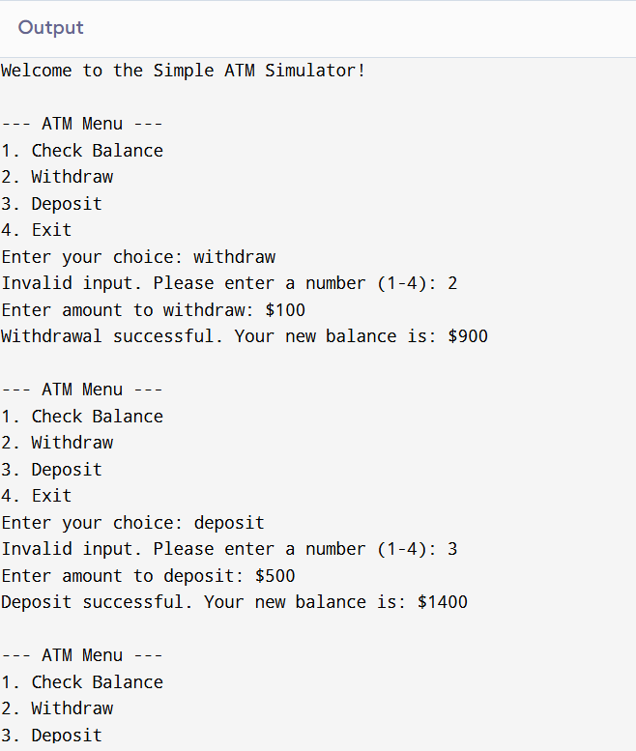
7. Output:
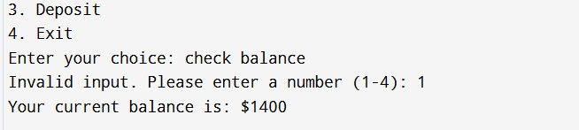

8. Conclusion
The ATM Simulator successfully performs all essential banking functions in a simplified form. The project provided hands-on experience
with C and C++ programming, focusing on file handling and class design. In the future, the system can be enhanced with a graphical interface,
multiple account management, and database integration for better performance and usability.

9. References
- Let Us C by Yashavant Kanetkar
- Object-Oriented Programming in C++ by E. Balagurusamy

